Intro to Engineering Systems, EG10111-09, Dr. Svarovsky

Pet Module Final Memo

Group 3-Meg Ryan, Jack Gergets, Sae Rome Choi, Griffin Collins, Josh Redoute

December 10th, 2015

x________________________________________________

x________________________________________________

x________________________________________________

x________________________________________________

x________________________________________________

**Pet Description**

This pet prototype resembles a lion consisting of the block as the body, four legs with wheels attached to each, a tail and a head. The body of the described pet prototype can be seen in Figure 1, below. The team believes that this pet prototype will be appropriate for the intended customer because lions are often of interest to children since they are not common in our geographic area. In addition, lions are a very active species and therefore are much more entertaining than a sedentary animal.

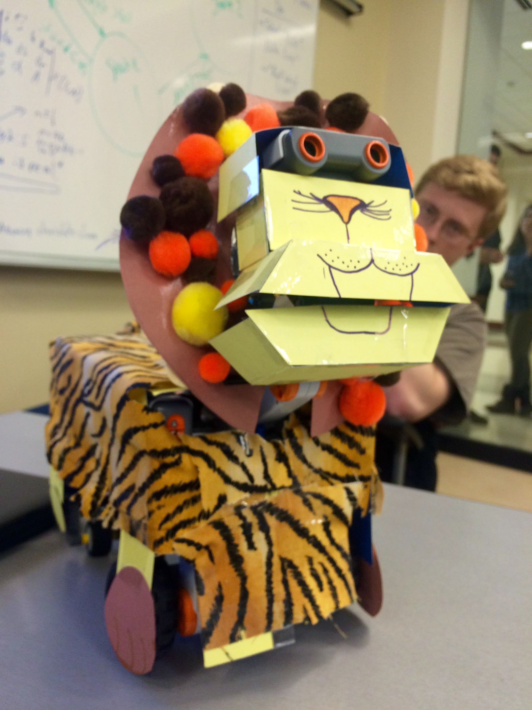

**Figure 1. Pet Prototype**

This pet will utilize programmed features such as roaring, which involves the lower jaw slowly opening wide while roaring loudly. Another feature that this pet possesses is the ability to eat, or move its lower jaw slightly opened and closed rapidly while displaying “OmNomNom” on its screen. Other features include locomotion with object avoidance, where the the motors attached to the front two wheels will rotate forward until the ultrasonic sensor reads a low value signaling the wheel motors to reverse and turn to the left, and awareness where the wheel motors turn the lion around after the sound sensors detect a loud sound.

**Analysis and Implementation**

Fortunately, all features worked as expected during demonstration. At one point, Griffin’s voice accidentally caused the pet to transition into State 3: Eating, although this was not believed to be an error in programming but instead due to an unusually loud voice. The transition path therefore slightly differed from what was intended, but quickly returned to what was planned. The summary of demonstration results can be found in Table 1, below.

**Table 1. Intended Transition Table**

|  |  |  |  |
| --- | --- | --- | --- |
| **Transition** | **Worked?** | **Technical cause for failure (if it didn’t work)** | **Fix Needed** |
| State 0: Resting → State 1: Locomotion | Yes | N/A | N/A |
| State 1: Locomotion → State 2: Roaring | Yes | N/A | N/A |
| State 2: Roaring → State 3: Eating | Yes | N/A | N/A |
| State 3: Eating → State 4: Awareness | Yes | N/A | N/A |
| State 4: Awareness → State 3: Eating | Yes | N/A | N/A |
| State 3: Eating → State 2: Roaring | Yes | N/A | N/A |
| State 2: Roaring → State 0: Resting | Yes | N/A | N/A |

**Process Reflection**

This design was very effective in being both interactive and enjoyable for customers of all ages, especially for children. For future designs, the team discussed making features more complex such as including locomotion in the roaring feature or adding sound to the awareness feature. In addition to making existing features more detailed, the team discussed creating more intricate features such as the dancing feature exhibited by numerous other prototypes on demonstration day. Other than the features, the pet prototype could have had an improved aesthetic if a stuffed lion was used to cover the K’NEX and Lego skeleton rather than construction paper. One possible improvement could be increasing the threshold value for the sound sensor to enter the third state so that unintended transitions such as the one that happened during demonstration are prevented.

In order to achieve these results, the team would prefer to spend more time on the analysis and implementation portions of the Engineering Design Process. Increased efforts in the analysis stage would allow for the team to become more creative in possible features (such as the dance feature). Likewise, focusing on the implementation of the prototype would improve how the team chooses to carry out these features in an effective manner, such as increasing the complexity of existing features. Emphasis on implementation would also improve the design by incorporating the stuffed animal idea into the final product.